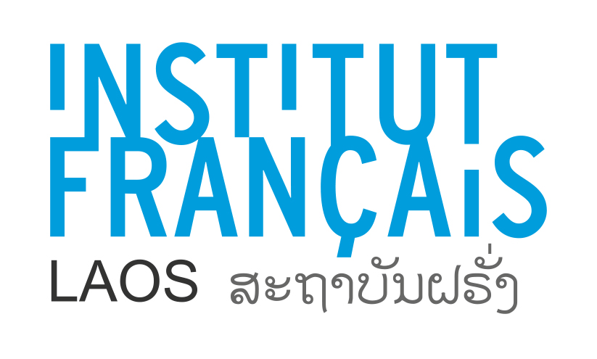
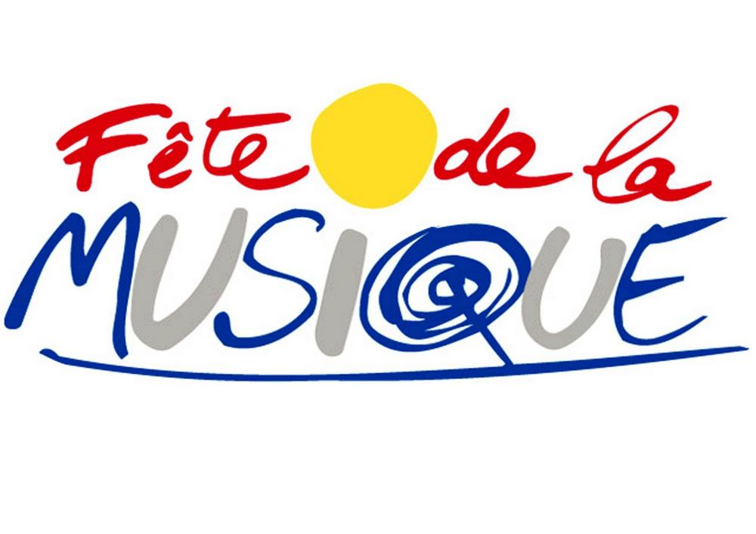

Fête de la Musique Music Day Laos 2022

Call for participation

The Fête de la Musique, or Music Day, is a large and popular event, free of charge and open to all musicians, amateurs or professionals. It celebrates music in all its forms and highlights the diversity of musical practices and all musical genres. Since its creation in France in 1982, the Fête de la Musique has grown considerably by becoming a national event in several countries. An iconic international musical event, the Fête de la Musique was celebrated in 2019 in more than 120 countries.

The French Institute of Laos calls on all singers, musicians and music groups, professional or amateur, of all genres (classical, pop, rock, jazz, traditional, world) to participate in a mega concert.
In order to participate, all you need to do is:
Send before 31 May 2022 a video to IFL for selection (1 or 2 pieces of music, with quality sound and image, in MP4 format or as an audio file). The selected groups will be invited to a big concert (sound, mixing, lights) at IFL on Saturday, June 18, 2022. A time slot of 15 to 45 minutes (depending on the wishes and the repertoire of the musicians), will be given to each musician or group. The event will take place on Saturday, June 18, 2022, from 16:00 to midnight.

A registration form must be completed by each musician or band and returned to the IFL before Tuesday, May 31, 2022, which is the deadline.

The registration form is available:
- in PDF format on the Institute's website: http://www.if-laos.org/
- upon request by mail sent to: fetedelamusique@if-laos.org

The Institute will provide a professional sound engineer, with a sound system, microphones, lights. Music Day being a free and voluntary event, no honorarium (remuneration of artist) will be awarded but a transport fee and a snack/drink will be provided to each musician.

Documents to be provided for registration:
- The registration form duly completed, dated and signed,
- a recording of the proposed song (s), in good quality, in MP4 format or as an audio file

For registration and any information, contact: fetedelamusique@if-laos.org

Registration Form

This form must be completed and returned to the Institut Français du Laos Vientiane no later than Tuesday May 31, 2022, preferably by email: fetedelamusique@if-laos.org

Name (musician or representative of the group):
First name:
Date of birth:
Nationality:
High school / University / Organisation (if it applies) :
Address:
Telephone:
Email:
Website / Facebook :

Musical style:
Description of the performance (1 ou 2 pieces, duration, language, etc.)
Groups will be able to play upto 8 pieces maximum, and singer or musician solo or duo will be allowed 3 pieces.

If group, name of the band:

Number of musicians:

Musical Instruments played:

Date:
Signature :

